



Nestle Infrastructure Architecture &

Recovery Structure- Azure

Contents

1. Nestle Azure Infrastructure Architecture 3

2. Backup & Disaster Recovery solution for Database server 4

2.1 Azure Server Architecture for Backup vault 4

2.2 Features Recovery services vault provides: 4

2.3 Backup strategy 4

2.4 ASR Replication structure for server over Azure 5

3. High Availability solutions for Virtual machine scale sets 6

3.1 Structure for Availability Zones 7

# Nestle Azure Infrastructure Architecture

# Backup & Disaster Recovery solution for Database server

## 2.1 Azure Server Architecture for Backup vault

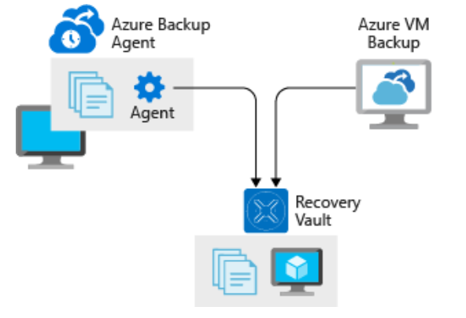

## Features Recovery services vault provides:

Azure Backup creates recovery points that are stored in geo-redundant recovery vaults. When you restore from a recovery point, you can restore the whole VM or just specific files.

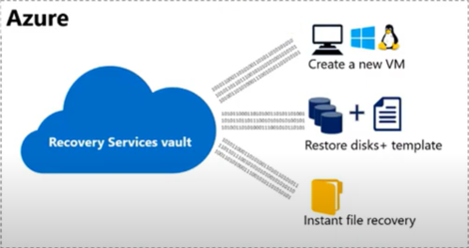

## Backup strategy

|  |  |
| --- | --- |
| **BACKUP STRATEGY**  **FOR SYSTEM** |  |
| Nestle Server | Daily complete Backup every 24 Hours |
| SQL Server Databases | Hourly Log Backups of SQL server Databases |
| Retention Period | 180 Days for server and 30 Days for SQL log backups |

Below screen shows the backup status and summary of recovery services vault for nestle server

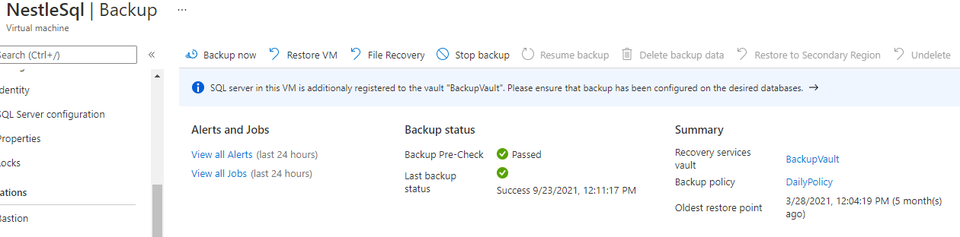

## ASR Replication structure for server over Azure

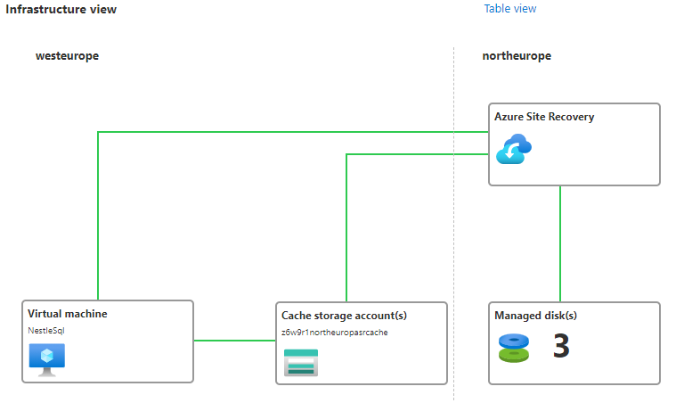

**Site Recovery Provide us:**

|  |  |
| --- | --- |
| **Azure VM replication** | we set up disaster recovery of Azure VMs from a primary region (west Europe) to a secondary region (North Europe). |
| **RTO and RPO targets** | Keep recovery time objectives (RTO) and recovery point objectives (RPO) within organizational limits. Site Recovery provides us continuous replication for Azure VMs and replication frequency as low as 30 seconds. |

# High Availability solutions for Virtual machine scale sets

For application and Dashboard servers we are using virtual machine scale sets.

VMSS Provides high availability and application resiliency

* Scale sets are used to run multiple instances of our application. If one of these VM instances has a problem, customers continue to access our application through one of the other VM instances with minimal interruption.
* For more availability, we use [Availability Zones](https://docs.microsoft.com/en-us/azure/availability-zones/az-overview) to automatically distribute VM instances in a scale set with across multiple datacentres in total 3 availability zones
* Availability Zones synchronously distribute the application and data.
* VMSS automatically distributed identical copies of servers continuously synchronized with data in 3 zones
* Allocation Policy:

Has maximum Spreading algorithm which allows more than 100 fault domains in availability zones.

## 3.1 Structure for Availability Zones

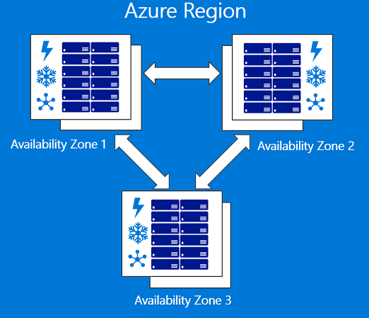

West Europe Region